SILENT HILL

LEVEL DESIGN DOCUMENTATION

Green Lion Pawnshop

Contents

1 Overview 2
2 Green Lion - Pawnshop & Apartment 3
3 Walkthrough: Pawnshop 4
4 Interactive Content 5
4.1 Cash Box 5
5 Puzzle - Pawn Shop Key 7
5.1 Overview 7
5.2 Puzzle Diagram ‘Pawnshop Key’ 8
5.3 Pawnshop Key Interaction 8
6 Memento 11
6.1 Double Ouroboros Ring 11
7 Zone Contents 12
7.1 Zone: Pawnshop 12
7.2 Shop reference images 13
7.3 Zone: Apartment 14

Overview
Harry has reached his destination, the ‘Green Lion Pawn Shop’ on ‘Simmons Street’, and enters the shop via the front entrance. Inside Harry discovers a locked door, which leads to the ‘Green Lion Apartments’.

Adjacent to the locked door is the pawnshop cashiers desk, which is enclosed within a security cage. Behind the cage is a shelf, on which is the key to the locked door. Harry must use his ingenuity to overcome a simple puzzle to get the keys, and use them to open the locked door.

Beyond the door is a small hallway, which leads up a flight of stairs to Dahlia’s apartment. As Harry nears the doorway to Dahlia’s apartment ‘IGC 36’ is triggered – where he meets an older version of his wife Dahlia.

Pawnshop has three subtle variations, which are altered based on the Harry’s current psych profile, which are:
- Punk
- Slut
- Junkie.

Green Lion - Pawnshop & Apartment
Location map:

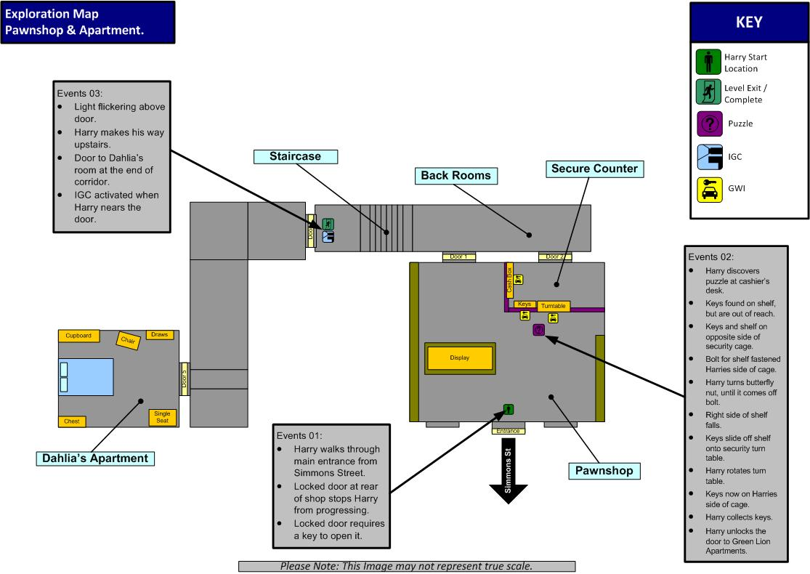

Walkthrough: Pawnshop
The following events take place whilst exploring the Pawnshop.

Events 01:
- Harry walks through main entrance from Simmons Street.
- Locked door at rear of shop stops Harry from progressing.
- Locked door requires a key to open it.

Events 02:
- Harry discovers puzzle at cashier’s desk.
- Keys found on shelf, but are out of reach.
- Keys and shelf on opposite side of security cage.
- Bolt for shelf fastened Harry’s side of cage.
- Harry turns butterfly nut, until it comes off bolt.
- Right side of shelf falls.
- Keys slide off shelf onto security turn table.
- Harry rotates turn table.
- Keys now on Harry’s side of cage.
- Harry collects keys.
- Harry unlocks the door to Green Lion Apartments.

Events 03:
- Light flickering above door.
- Harry makes his way upstairs.
- Door to Dahlia’s room at the end of corridor.
- IGC activated when Harry nears the door.

Interactive Content
Below are all of the GWI available in the Green Lion:

Cash Box
Cash box diagram:

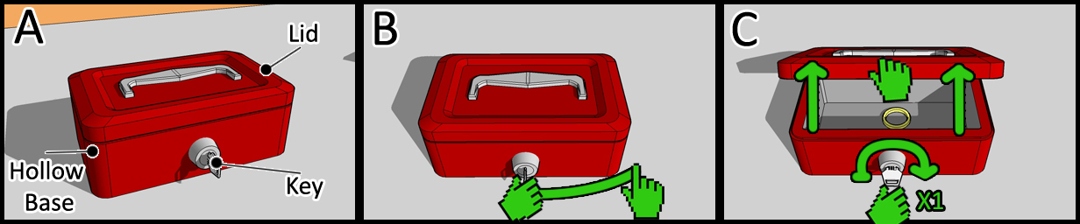

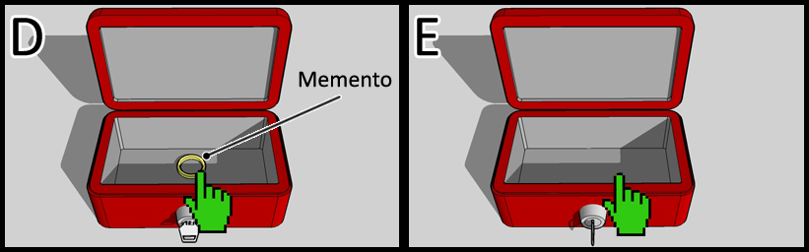

Description
After completing the key puzzle, Harry finds an entrance to the cashier’s side of the counter. A small potable cash box is found on a shelf. Harry is able to unlock and retrieve a memento from within the box.

Interaction
- Press ‘A’ to enter POV near ‘Cash Box’.
- Whilst in POV mode – select the key with the cursor.
  - Press and hold ‘A+B’ when key is selected.
- With ‘A+B’ held, make one full clockwise twist to unlock ‘cash box’.
  - Next, grab the lid of cash box by highlighting the lid and pressing ‘A+B’.
  - Make an upward gesture with the Wii-remote to open the lid.
- A ‘ring’ memento is discovered inside.
- Highlight memento with cursor and press ‘A’ to collect it.
  - Memento stored.

Visual Assets:
- Animated lid
- Animated key turn
- Ring memento.

Audio Assets:
- Key turn
- Opening lid
- Memento awarded sound.

Puzzle - Pawn Shop Key

Overview
Harry must obtain a set of keys placed on a shelf that is attached to a security cage, which protects the cashier from possible violence. Shelf is held in place by a flimsy looking brace, secured to the cage by a bolt and butterfly nut. The nut is interactive, in that it is twistable, in a clockwise direction.

To the right of the shelf, and a foot or so below is a security turntable or carousel, used for exchanging money and small goods. Harry is able to rotate the turntable, which brings the cashier’s side of the turntable around to Harry.

Now that Harry has observed these two elements, he may begin unscrewing the butterfly nut. On completion, the bolt becomes slack, causing the right side of the shelf to drop. The keys also fall, sliding down the shelf and onto the security turn table below. Harry rotates the turntable, brining the keys from the cashier’s side of the cage, around to Harry – puzzle solved.

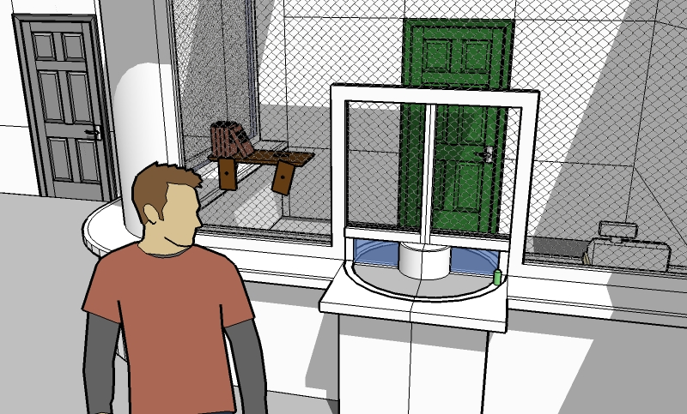

Puzzle Diagram ‘Pawnshop Key’

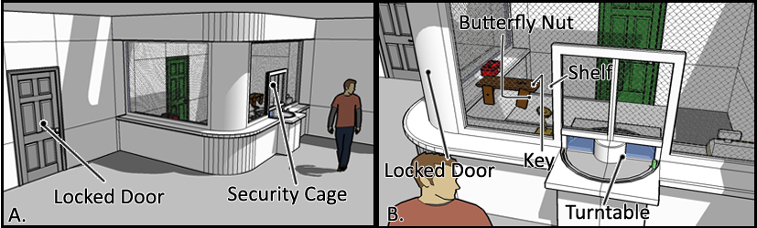

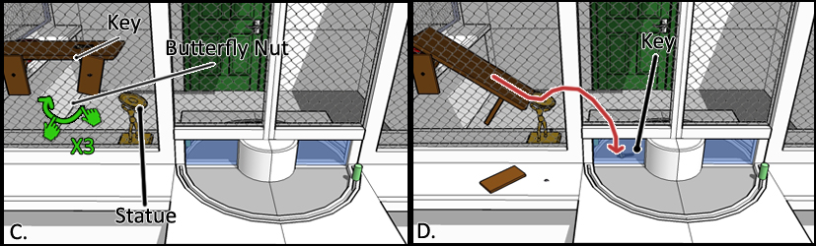

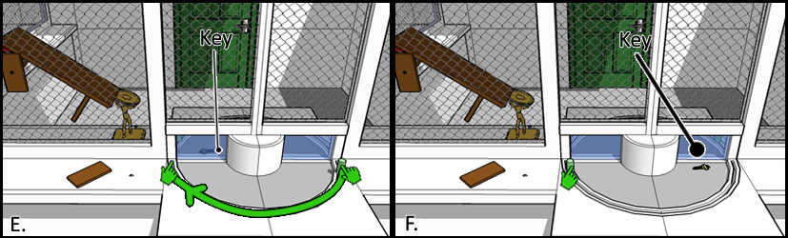

Pawnshop Key Interaction
The ‘Pawn Shop Key Puzzle’ is completed by performing the following:

- Harry must retrieve key to exit shop.
- Key found on a shelf on the opposite side of cage.
- Harry clicks ‘A’ to activate a POV camera.
  - Camera angle positioned for optimal view of puzzle area.
  - Harry interacts with shelf unit.
  - Shelf fastened to security cage by two bolts.
  - Each bolt has a butterfly nut.
  - Only one of the nuts is interactive, as the other is old and worn.
  - Harry presses ‘A+B’ to grab the nut.
  - Harry twists the Wii-remote three times clockwise to slacken blot.
- On completion of the last twist, the shelf collapses.
  - Edge of the shelf collides with a statue holding an angled surface – key slides onto surface. (Statue is waiter holding plate of pizza)
  - Key slides off the surface – landing on the carousel below.
  - Turntable is positioned so that the keys always land on it.
- Harry is now able to retrieve the keys using the turntable.
  - Harry grabs the turntable by pressing ‘A+B’.
  - Making a clockwise rotational gesture using the Wii-remote, Harry rotates the turntable.
  - Once fully rotated the turntable locks in place.
- Harry collects the keys by clicking ‘A’.
  - Key icon displayed onscreen.
  - Harry may press ‘-‘at any time to exit POV camera.
  - Once the key has been used it is removed from Harry’s inventory.
  - Onscreen key icon removed.
  - Key unlocks door.

Puzzle Notes:
- The interactive butterfly nut looks new and shiny, whereas the non-interactive nut should look rusted, worn out – missing parts that make it a butterfly nut.
- The turntable can be interacted with at anytime regardless if the key is on it or not.
- Parts of the turn table are made of glass, so Harry can see the key.
- Items on the shelf aid Harry in tracing the falling trajectory, as the key might be too hard for some users to see.
- Turntable must have a rubber band behavior, in that the table returns to its original state is Harry release his grip on it.

Assets:
The following assets are required to implement “Puzzle 01”:

Visual:
- Shelf.
- Turntable.
- Keys.
- Butterfly nut.
- Bolt
- Worn butterfly nut + bolt

Audio:
- Nut unscrewing
- Bolt falling
- Shelf rubbing cage / impact
- Keys sliding / hitting turntable
- Turntable rotating / locking.

Reference Images:

Statue / Figure:
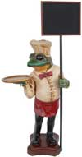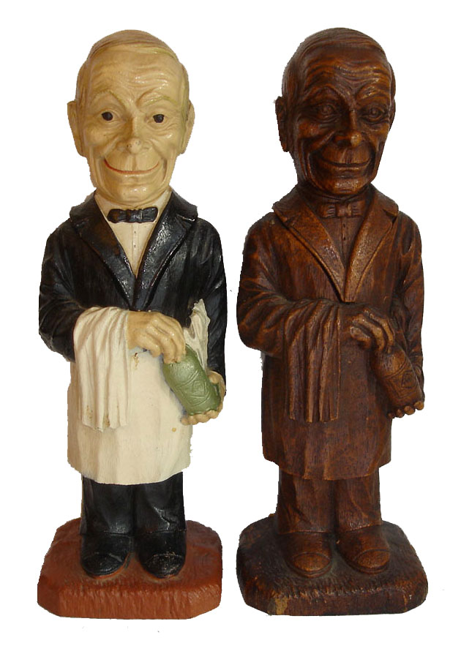

Small wooden statue holding a tray, on which a pizza or pastry is ready for serving, with a wholesome smile. Statue is comical, old, and showing signs of wear and tear – it probably originated from a 50’s diner / restaurant.

Memento
The following Memento is discovered whilst examining objects within the environment:

Double Ouroboros Ring

Description
- Description: “Pewter ring of two snakes eating each other's tails.”
- Object: “On the inside of the ring is written: "Love is a hungry drug”
- Location: “Located on the windowsill of Michelle’s apartment”

Memento Reference image:

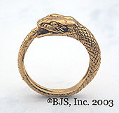

Zone Contents

Zone: Pawnshop

Zone Description:
Pawnshop is a rather simple place filled with a variety of items, ranging from antiques to rugs. It’s a small place, almost cozy, but still maintaining an empty solitude that chips away at Harry’s resolve.

The proprietor must be quite paranoid, as his counter is enclosed within a thin, yet strong metal cage. He has even gone as far as to install a carousel security device.

In terms of size and layout, the shop is somewhat simple, small and easy to navigate, as there are not many shelves in the way of the customer. Most items are displayed on the outer walls of the shop, not in a central space.

To the left of the room is a table, on which is displayed one of three models, made visible depending on Harry’s psych evaluation. A plaque accompanies each model, with simple inscription related to the model. The models and inscriptions are as follows:

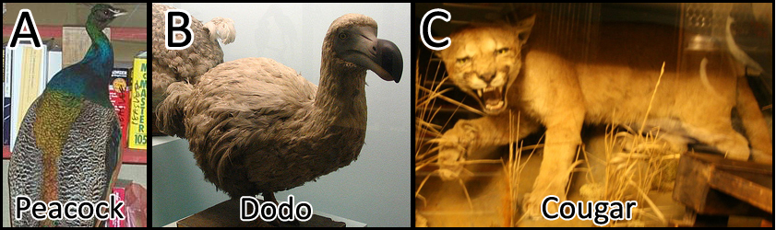

- Punk: Stuffed Peacock.
  - Plaque reads: “Shine Brightly”
- Junkie: Stuffed Dodo
  - Plaque reads: “Poor, poor clumsy bird”
- Slut: Stuffed Cougar.
  - Plaque reads: “On the Prowl”

Pawnshop has three distinct lighting rigs based on Harry’s current psych profile, which are:
- Punk – Green tones.
- Slut – Red tones.
- Junkie – Yellow tones.

Zone Contents
Zone Contents as follows:

- Puzzle x1
  - Pawn Shop key
- Changeable x3
  - Lighting
    - Punk
    - Slut
    - Junkie.
  - Model swap – display unit.

Shop reference images
Following images are a guide only, and do not represent final art quality.

Pawnshop:
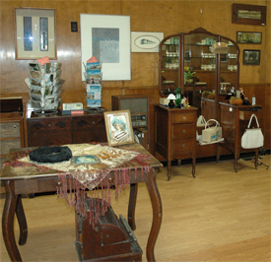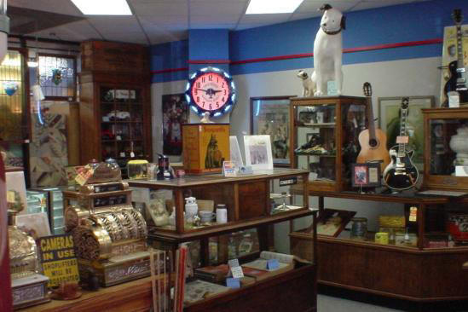

Zone: Apartment

Zone Description:
Dahlia’s apartment is an IGC zone, so the user is not at any time able to explore the apartment.

Subtle lighting and scene alterations are present during the IGC, based on the three psych evaluations, which are ‘Punk’, ‘Slut’, and ‘Junkie’. In terms of model and texture changes, these are small and featured around the bed area.

Texture alterations are required for the bed itself, conforming to the three types:
- Punk – Torn in places, were once white.
- Slut – Red silk sheets.
- Junkie – Horribly stained, with traces of cigarette burns.

Model alterations to the room are as follows:
- Punk – Poster / picture on the wall of Fist / Boot smashing glass or window image is black and white.
  - Bed slightly untidy – miss-matched pillowcases and quilt.
- Slut – Seductive bedding, including clothing draped across bed.
  - Athena picture on the wall behind. (B&W couples picture)
- Junkie – Messy bedding, burn holes in the sheets.
  - Cigarette cartons, pizza and alcohol laying on the bed and floor.

In addition to the altering textures and models, are three lighting variants, which are:
- Punk – Green tones.
- Slut – Red tones.
- Junkie – Yellow tones.

Zone Contents
Zone Contents as follows:
  - IGC x1
  - Changeable x3
    - Punk
    - Slut
    - Junkie.

